

SCHOOL OF SCIENCE AND TECHNOLOGY
SOFTWARE ENGINEERING 2
MODULE CODE: SOFT40141

Analysis, design and implementation of a film management system for TrekStar Pictures
SUBMITTED
BY
PURNIMA MALNEEDI
STUDENT ID: N0768969
SUBMITTED TO
Dr.Tao Chen

Submission Date: 29-03-2018

Contents

Introduction 3
1. Use Case Diagram 4
2. Class Diagram 5
3. Sequence Diagram 6
4. State Diagram 6
5. Component Diagram 7
6. Deployment Diagram 7
7. Design Pattern 8
8. Internal Data Structures 9
9. Implemented algorithms and Database Structure 10
10. User Manual Instructions 12
11. References 13

Introduction

This is a project management system for TrekStar Pictures, which facilitates customer/user to browse the projects information with the keywords such as project title, material number, and added date etc., Also system will allow user to search for different materials launched together with the film and can choose any product of his choice.

This application contains some easy navigational and silent features to guide the users while shopping. The search facility helps the users to find exactly what they desire without wasting much of their time. The shopping cart summary serves as a reference for the customer as they continue to browse for more products. The other facilities include advanced search, progress steps, related products, sorted search results, etc.

The application is made user-friendly and expedient to such an extent that the user is indeed not essential to type the same information more than once.

Similarly the project comprises a managerial control center. From where the managers/administrators can have different logins and can able to manage each aspect of the project. Such as he/she can view and add the projects and materials to the project. System will allow authorized managers to make changes to the projects and keep the records up to date about the current projects and track all materials information corresponding to the each film/project. In a nutshell, admin has total control on all the features of the system.

PURPOSE

The goal of this project is to develop a generic user interface application. The accessibility of being able to search anything from a project to a material at the comfort of your home without having to travel has made online a massive success. So easy convenience of the customer is one of the basic intentions of this application.
A user-friendly environment helps the user to search for what they want with great ease and efficiency. Moreover it also helps the Trekstar pictures to attract more customers. So developing a user-friendly interface can also be considered as one of the goals.
In short the key goals are getting in the top visitors, promoting films and the materials.

SCOPE
Project scope basically states the size of the project in terms of what it will contain.
The scope of this project contains the following features:
- Enables managers for easy adding, deleting and modifying of projects and the relevant materials information.
- Secure authentication system.
- Allows users to search for projects and different materials of their choice.

Use Case Diagram
Use cases is a methodology to identify, establish and clarify the requirements of the system. This will be normally created in the analysis part of the system.
Please find the use case diagram for the Trek Star film management System below.
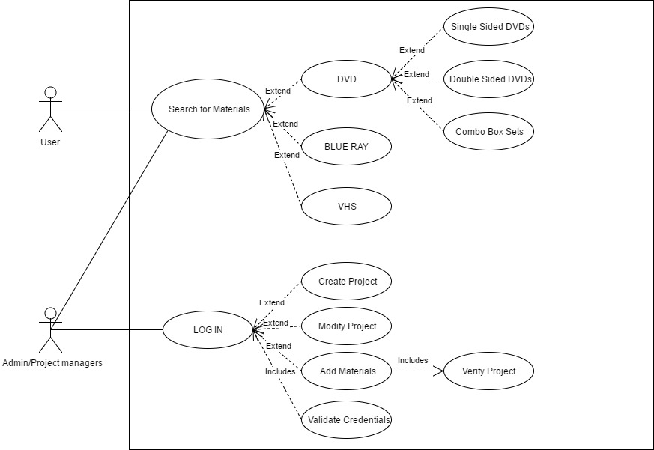

Class Diagram
Class diagram is drawn from the attributes, assosiations and operations of the above use case. This is shown below [1].
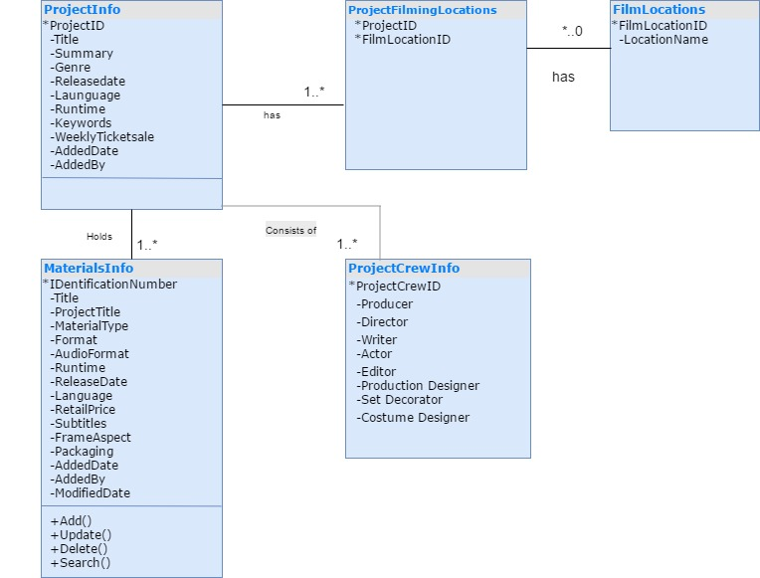

Sequence Diagram
Sequence diagram for the MaterialSearch Class is shown below.
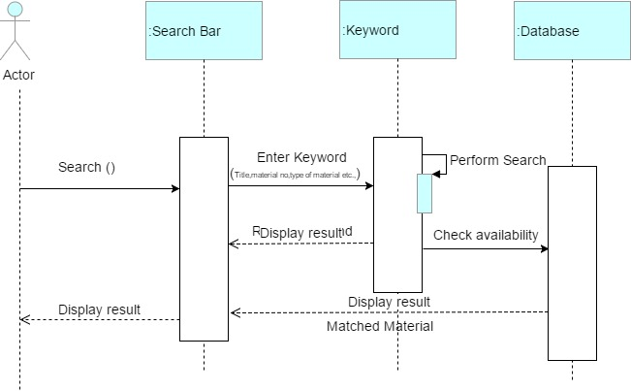

State Diagram
A State Diagram for the Search Material class is show below [2].
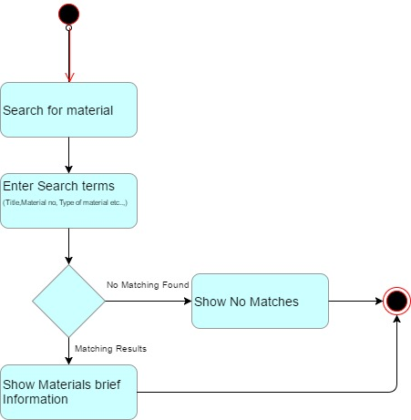

Component Diagram
Component diagram for the whole system is shown below.
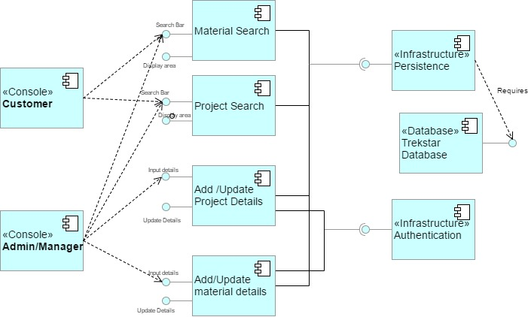

Deployment Diagram
A deployment diagram for the whole system is shown below.
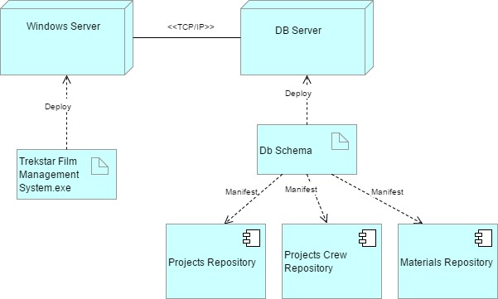

Design Pattern
An architectural pattern that used commonly to develop the user interfaces is Model-view-controller (MVC). MVC divides the application into three parts, which connected internally. Using MVC design patterns efficient code reuse and parallel development can be achieved. This architecture is very popular for designing the client, mobile, desktop and web applications. [3]
Below are the three interconnected parts of MVC
Models:
Application central functionality holds by model. And all dependent controller and view components are know to the model.
Model basically contains the data, which allows the different set of operations on that data. And also model has logics and rules that provide the access and data updates throughout the application.
Views:
Views uses as presentation layer for users. Presentation layers are formatted with different styles by using different methods. And also presents the information (data) to users in different formats.
Data displays in views are retrieved from model and the views presentation updates when data changes in one of other views. Associated controllers created by views.
Controllers:
User inputs accept as events on every view and all these events translates to perform the operations on data within the model. Controller optionally validates the input passed from the views and passes the provided input to model for data updates.

Internal Data Structures

The below five classes are used to develop the application.
MaterialView.cs -> View, User Interface [Presentation layer]
MaterialModel.cs -> Model [Uses for data operations]
MaterialControllerMain.cs -> Controller, Provides the input events from view to model.
MaterialDatabaseActivity.cs -> Data adapter for internal data structure
IMaterialDatabaseActivity.cs -> Interface for Data adapter.
When application is launched user will be provided with console view. Asking the user for input on console to translate that input to controller to trigger the model for updating and searching the data.
In the main controller objects are created for model, view and data adapter. Materialmodel list is declared in the same controller. From the controller 2 view class methods are called one after one. Those method are
initialse() – First view to user displays and identifies normal user or admin user
userOptions() – After identifies the user application provides four options [Search Material, Create Material, Update Material and Delete Material] to user to go further
When users choose the option in view. Controller calls method in view by passing model object as a parameter for this method. Again provides the different options for user on view. Based on the user selection model class properties are set with data. After that MaterialDatabaseActivity Interface method calls with the model class data properties set. MaterialDatabaseActivity Interface which implements the methods in MaterialDatabaseActivity class.
Methods in MaterialDatabaseActivity class initiate the sql connection and prepare the sql command based on the user selection. Data used in the sql commands is provides by model object. Opens the SQL connection and performs the required actions and close the sql connection and return the data back to MaterialDatabaseActivity Interface. Which passes the information back to controller by setting the new data back in model. And controller invokes new method in view to display the updated information through get properties of model class.

Implemented algorithms and Database Structure
I have used set 3 to implement the material management. I have created SQL Server database called ‘TrekStarFilms’ to store the projects and material information.
Please find the below database structure.
ProjectFilmingLocation
Column_name | Type | Length
ProjectID | int | 4
FilmLocationID | int | 4
ProjectInfo
Column Name | DataType | Length
ProjectID | int | 4
Title | varchar | 100
Summary | varchar | -1
Genre | varchar | 20
ReleaseDate | datetime | 8
Language | varchar | 10
Runtime | time | 5
Keywords | varchar | 100
WeeklyTicketSale | money | 8
AddedDate | varchar | 50
AddedBy | varchar | 50

FilmsLocations
Column_name | Type | Length
FilmLocationID | int | 4
LocationName | varchar | 100
MaterialInfo
Column_name | Type | Length
IdentificationNumber | int | 4
Title | varchar | 100
ProjectTitle | varchar | 100
MaterialType | varchar | 100
Format | varchar | 50
AudioFormat | varchar | 20
Runtime | time | 5
ReleaseDate | datetime | 8
Language | varchar | 10
RetailPrice | float | 8
SubTitles | varchar | -1
FrameAspect | varchar | 50
Packaging | varchar | 100
AddedDate | varchar | 50
AddedBy | varchar | 50
ModifiedDate | varchar | 50
Each table is used to store unique information related to the project and materials.
ProjectInfo – This table stores the all project related information.
FimsLocations – This stores the all the locations available where films are showing.
ProjectFilimgLocaton – This stores the filming locations for each project.
MaterialInfo – This stores all the material info. Project Title is also used Materials to identify the materials using project title.
I have inserted some predefined data for the projects and all the materials will be created by the admins using the implemented application. All the unique identification numbers will be auto generated by SQL server.
I have Created ‘MaterialDatabaseActivitySQL’ for all database related activities. I have created separate method for each user action like Create, Update, Delete and Search. All the SQL statements for each method is given below.
Search:
Searching materials is based on title, identificationNumber, Addeddate or Material Type. All the parameters will be passed from user input. This may return more than one material.

SELECT * FROM dbo.MaterialInfo
WHERE ProjectTitle = @ProjectTitle OR IdentificationNumber = @IdentificationNumber OR AddedDate = @AddedDate OR MaterialType = @MaterialType
Insert:
INSERT INTO dbo.MaterialInfo (Title,ProjectTitle,MaterialType,Format,AudioFormat,Runtime,ReleaseDate,Language,RetailPrice,SubTitles,FrameAspect,Packaging,AddedDate,AddedBy) VALUES (@Title,@ProjectTitle,@MaterialType,@Format,@AudioFormat,@Runtime,@ReleaseDate,@Language,@RetailPrice,@SubTitles,@FrameAspect,@Packaging,@AddedDate,@AddedBy)
Update:
UPDATE dbo.MaterialInfo
SET Title = @Title,ProjectTitle = @ProjectTitle, MaterialType = @MaterialType, Format= @Format,AudioFormat = @AudioFormat, Runtime = @Runtime ,ReleaseDate = @ReleaseDate,Language = @Language ,RetailPrice = @RetailPrice, SubTitles = @SubTitles, FrameAspect = @FrameAspect, Packaging = @Packaging ,ModifiedDate = @ModifiedDate
WHERE IdentificationNumber = @IdentificationNumber
Delete: I have only used identification number to delete the materials. User should Identify the material identification number from search function and then delete the material if he wants.

DELETE FROM dbo.MaterialInfo WHERE IdentificationNumber = @IdentificationNumber

User Manual Instructions
‘TrekStartFilmManagement’ application has got different features for admins and normal users.
A step by step instructions for both type of users is given below.
Admin Users:
- Launch Console Application.
- Admin should give password ‘admin1234’ to check for the available operations.
If admin enters wrong password it will prompt again.
- Admin will be given 4 different options to choose his action. You should enter 1 to 4.
  - Search Material
  - Create Material
  - Update Material
  - Delete Material
- If admin chooses option 1 which is to search material. Then the below options will be displayed to the user for the search criteria. User should have to select one based on the details that he has got.
- Project Title
- Material Number
- Added Date
- Material Type
- Based on the selected search criteria corresponding input will be asked by the user. Once user enters input then corresponding matching materials will be displayed to the user. If there is no match found then ‘No materials found’ message displays to the user.
- If User chooses option to create material then all required fields (Title, Project Title, Material Type, Format, Audio Format etc..) will prompted one by one to user. Some fields will be clearly shows required input format (Example: RunTime (hours:mins:secs)). If the user enters incorrect format then exception will be thrown. Once user submits all the inputs then material will be created in the database.
- If User chooses Update material option then all the above fields along with Identification numbers will be prompted to the user. User should give all the inputs. If the material found with the given Identification number then details will be updated.
- If User selects delete material option then only identification number will be prompted to be given by the user. The corresponding material will be deleted from the database if it exists.
Non Admin Users: Non admin users only be given search functionality which is exactly the same as admin users. This is explained in the step 4 above.

References

- Beriwal, A. (2018). Online Movie Ticket Booking - Class Diagram. [online] Umldiagramtutorial.blogspot.co.uk. Available at: http://umldiagramtutorial.blogspot.co.uk/2012/12/online-movie-ticket-booking-class.html [Accessed 26 Mar. 2018].
- AHER, N., AHER, N., AHER, N. and AHER, N. (2018). state chart diagram for inventory management system. [online] Java Engineering Programs. Available at: http://www.javaengineeringprograms.com/state-chart-diagram-for-inventory-management-system/ [Accessed 28 Mar. 2018].
- Leff Avraham, James T. Rayfield, "Web-application development using the model/view/controller design pattern", Enterprise Distributed Object Computing Conference 2001. EDOC'01. Proceedings. Fifth IEEE International, 2001.

Plagiarism Declaration:
This report and the software it documents is the result of my own work. Any contributions to the work by third parties, other than tutors, are stated clearly below this declaration. Should this statement prove to be untrue I recognize the right and duty of the Board of Examiners to take appropriate action in line with the university’s regulations on assessment.

Name: Purnima Malneedi ID No: N0768969

